**Query and Retrieve (Q/R)**

* What is Q/R?
* How does Q/R work?
* How do I know which sites have Q/R?
* Why is Q/R slower to load images?
  + Once it is fully loaded, it will store on a temp DB for 24 hours
* What happens if I call a site for a prior that was already pulled by Q/R? Will there be a conflict?
* If a prior was already sent to Avreo, will that also be available for Q/R?
* How do I enable Q/R in Avreo?

**What is Q/R?**

Query/Retrieve allows Avreo to communicate with a local PACS server (or VNA) to query (search) for prior studies, and retrieve the study if available.

**How does Q/R work?**

When a study is opened, Avreo will automatically perform a “CFIND” against the local PACS for a list of prior imaging for a particular patient and populate this list of prior studies in the “MPI Candidates” folder. Screenshot below:

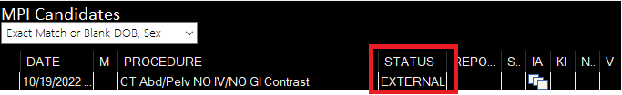

Studies stored on the local PACS will be notated as “EXTERNAL” underneath the status column. Click the icon underneath the image archive (IA) column to pull the prior. Upon clicking the icon, Avreo will perform a second “CFIND” for the prior, then a “CMOVE” to retrieve/pull the prior into our server.

Studies pulled via Q/R will be stored on Avreo in a temporary database for 24 hours. Note, only studies that are completely downloaded will store on the database. Priors stored on the temporary database will transfer significantly faster.

**How do I know which sites have Q/R?**

The location tab will notate sites with Q/R. Screenshot Below:

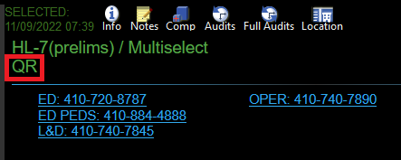

**Why is Q/R slower to load images?**

Transfer speeds via Q/R will vary site by site. It depends on various factors, such as their PACS server, software, hardware configurations, routing rules, etc. One primary factor will depend on how quickly the local PACS can find images in the database and transfer the prior.

**What happens if I call a site for a prior that was already pulled by Q/R? Will that conflict?**

Priors retrieved via Q/R will store on a temporary database. If the same prior is manually pushed from the site, it will store on our permanent database without conflicting with the prior on the temporary database.

**If a prior was already sent to Avreo, will that also be available for Q/R?**

Yes.

**How do I enable Q/R in Avreo?**

Settings->General Defaults->MPI: “Exact Match or Blank DOB, Sex.”

